

 | 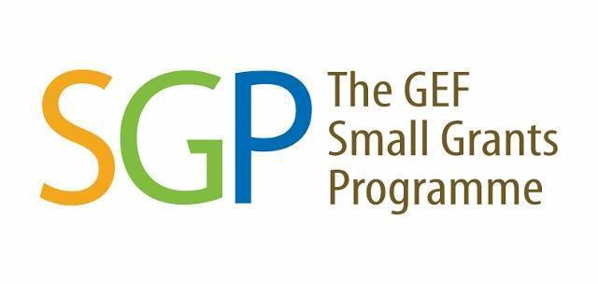 |  | 

TERM OF REFERENCE FOR

THE SMALL GRANTS PROGRAMME (SGP)

Call for Concept Proposals

Location:
Crocker Range Biosphere Reserve, Sabah

I. Background

The Small Grants Programme (SGP) provides grants to NGOs, CBOs and local communities for community level conservation, restoration and sustainable livelihood interventions. The seventh Operational Phase (OP7) of the GEF Small Grants Programme (SGP) in Malaysia aims to build upon the long-standing achievements of SGP in the country, specifically involving strengthening civil society organisations and improving socioeconomic conditions for local communities through the implementation of participatory conservation, restoration, and climate change mitigation interventions.

Starting in OP7, Malaysia has been included in the Upgraded Country Programme (UCP) of the SGP. With the aim of achieving impacts at scale and ensuring the sustainability of results achieved, the programme level strategy of the UCP is based on a landscape approach, following the UNDP approach of community-driven planning and management of socio-ecological production landscapes and seascapes. The three selected landscapes (Crocker Range Biosphere Reserve in Sabah; the Middle and Upper Baram River Basin in Sarawak; and the Klang Valley in Peninsular Malaysia) cover expansive and complex rural and urban geographies.

In OP7, the project in Crocker Range Biosphere Reserve (CRBR), Sabah aims to foster collaboration among regional community organisations in the landscape. This collaboration aims to promote socio-ecological resilience, benefitting the global environment and facilitating sustainable development. In addition, the project promotes activities related to forest conservation within the targeted landscapes, community livelihood improvement, community participatory in biodiversity conservation and restoration, landscapes undergoing improved practices, policy reforms for the sustainable resource management and climate mitigation projects.

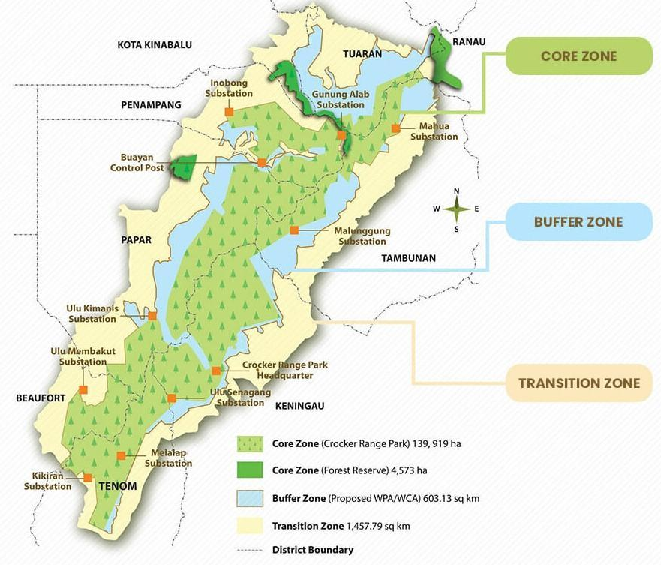
Figure 1: The scope of area will be in the buffer and transition zone of the Crocker Range Biosphere Reserve. (Source: Crocker Range Biosphere Reserve, Man and Biosphere (MAB), 2023)

The project aims to reach about ~3150 direct beneficiaries, 50% of whom are women, and will facilitate community-driven interventions that generate global environmental benefits, including bringing an estimated 16,000 ha of landscapes under improved practices (9,000 ha under improved management to benefit biodiversity and another 7,000 ha under sustainable land management in production systems); restoring 200 ha degraded agricultural lands and 100 ha forest lands; as well as mitigating greenhouse gas emissions equivalent to 335,000 tonnes of carbon dioxide in agriculture, forestry and other land use sectors and avoiding about 6,500 CO2e through energy efficiency and renewable energy; from all the projects executed under the SGP within the Crocker Range Biosphere Reserve landscape.

The Crocker Range Biosphere Reserve landscape strategy has been developed by the PACOS Trust team with close consultation with stakeholders. The strategies developed will provide guidance to the selection and prioritisation of these actions to be addressed by community-level projects. The project’s landscape approach provides an ecological and socio-economic framework for participatory biodiversity conservation and restoration initiatives, sustainable agroecological practices, and restoration of degraded land and forest ecosystems. Community level activities are also designed to strengthen capacities for community-level renewable energy (RE) and energy efficient (EE) solutions. Community grants will enable development of proven technologies such as micro- and pico- hydroelectric, energy efficient lighting systems, effective cook stoves etc., as well as the broader adoption of successful applications. All the applicants of this call should refer to the Crocker Range Biosphere Reserve Landscape Strategy and ensure the proposed activities in the proposal align with the strategy.

II. Project Objective

To enable community organisations to take collective action for adaptive landscape management in building socio-ecological resilience in the Crocker Range Biosphere Reserve, Sabah for global environmental benefits and sustainable development.

III. Scope of the Assignment and Indicative Activities

Competent organisations are encouraged to submit an application on the basis of the Call for Proposals below. The proposals will be reviewed and approved by the SGP National Steering Committee (NSC).

All project activities must also be in line with the landscape strategy developed by the landscape strategy grantee. In the process of developing the project’s proposal, it is crucial to consider the following focuses (either one or more than one) in the overall project’s strategy.

The Crocker Range Biosphere Reserve Landscape Strategy seeks to reach this objective by pursuing the following four target outcomes by 2026:

- 300 hectares of land restored;
- 16,000 hectares of landscapes under improved practices;
- Greenhouse gas emissions mitigated equivalent to 335,000 tonnes of carbon dioxide; and
- 3,150 individuals directly benefiting

This will be accomplished and aided by SGP grant-funded projects within the Crocker Range Biosphere Reserve, led by NGOs, CBOs, and local communities.

The potential projects include the following (but not limited to):

- Biodiversity and Land degradation

- Vegetation restoration and reforestation: Plant native trees and fruit trees, shrubs or grasses that are adapted and suitable to the microclimate and soil condition of the degraded site; invasive species management.
- Physical intervention and enhancement: Create diverse habitats such as wildlife corridors, wildlife crossings, provide suitable breeding, nesting sites and food source for both native and migratory wildlife.
- Water catchment management and restoration: Restore natural hydrology to regulate water flow and improve water quality; control soil erosion and sedimentation.
- Land restoration through agroforestry, climate-resilient agriculture, regenerative agriculture or sustainable agriculture practices (including planting of cash crops, other vegetables, herbs, fruits, poultry for self-subsistence and/or socio-economic activities; planting rattan, bamboo for handicraft etc.).
- Seed collection and plant/tree nursery for land restoration.
- Syntropic farming and/or other effective crop management and harvesting approaches that are practical for communities.
- Restore the forest ecosystem to re-establish wildlife habitat and conserve existing wildlife habitat.
- Establishment of Tagal areas and other indigenous and community conserved areas (ICCAs).
- Legal protection and improvement of land management over the existing and proposed indigenous and community conserved areas (ICCAs).
- Participatory conservation and restoration of forest ecosystems in partnership with government agencies and other partners to benefit biodiversity and community in the CRBR landscape.
- Community forest and land management through capacity building and engagement with relevant authorities and other stakeholders.
- Development of community-based monitoring and information systems to improve management of landscape.
- Documentation of traditional knowledge related to biodiversity and natural resource management.
- Development of nature-based economic opportunities for local communities
- Development of community-based monitoring and information systems to improve management of landscape.
- Cultivation of carbon-sequestering plants such as bamboo.
- Restoration and enrichment of degraded land and/or agriculture ecosystems through tree planting, agroecological and sustainable agriculture practices and other nature-based approaches.

- Climate Change Mitigation

- Development of energy efficient and renewable energy technologies such as:
  - Fuel-efficient cook stoves
  - Solar pump
  - Gravity fed water system for household use and irrigation
  - Micro- and pico- hydroelectric generators for off-grid communities
  - Solar PV for off-grid communities
  - Biogas (at community level) for cooking
  - Gasification system and turbine generator producing both power and biochar.
- Replacement of incandescent lamps and oil lamps with LED lights and solar lights
- Sustainable agriculture waste management system and practices to reduce waste and pollution
- Establish supply chains and improve logistics for more efficient transport of products to market.

- Policy Reform and Establishing Multi-stakeholder Landscape Governance Platform

To learn more about this thematic area, interested organisations should contact the SGP secretariat.

An integral aspect of the project’s landscape approach is establishing or strengthening multi-stakeholder landscape governance platforms by providing local communities with enhanced opportunities to participate in development planning. The project will facilitate multi-stakeholder platforms in the project landscapes, with representation by local civil society organisations, state and local government departments, private sector enterprises and/or associations, women’s groups, and others. Preference will be given to linking into and strengthening existing multi-stakeholder platforms. Additionally, applicants for this thematic area will be required to assist in partnership building and policy advocacy among governmental stakeholders, civil society, financial institutions, and the private sector for facilitating broader adoption of participatory approaches supporting landscape approaches, delivering advocacy for policy reform, and facilitating upscaling.

Projects under this MUST ensure all the indicative activities below are included in the proposal:

- Engaging with key stakeholders in Crocker Range Landscape, agree upon the best approach for multi-stakeholder landscape governance platforms and prepare terms of reference for the platforms.
- Convene regular meetings of the multi-stakeholder landscape governance platforms, discuss landscape strategies, link with complementary initiatives, facilitate capacity building, organise strategic awareness campaigns, etc.
- Sensitise and build the capacity of stakeholders on gender mainstreaming and inclusion of indigenous peoples and other marginalised groups.
- Advocate and assist local government units in mainstreaming the multi-stakeholder platforms into local governance structures.
- Based on evaluations of portfolio results and lessons, prepare policy briefs to advance the enabling environment for incentivising participatory approaches.
- Advocate for policy reform through liaising with key stakeholders and convening stakeholder workshops, inviting local and national government officials, financial institutions, donor agencies, civil society, private sector, and research-academic institutes.
- Delivering technical and strategic support, guiding local stakeholders in implementing landscape approaches and providing advocacy for policy reform and upscaling.

IV. Eligible Organisations and Funding Criteria

- Locally registered Non-government Organisations (NGOs) / Civil Society Organisations (CSOs) / Community-based Organisations (CBOs), with an existing copy of the certificate of registration.
- Locally registered bank account of the organisation.
- In exceptional circumstances, unregistered organisations may contact the SGP Secretariat to discuss the potential arrangement of an intermediary contract with an established organisation.
- Applicant organisations must demonstrate that it has the capacity to implement the project and meet SGP’s administrative and book-keeping requirements.
- Applications may be written in either English or Bahasa Malaysia.
- Applications must be complete and submitted using the provided template (Concept Proposal Template). All applications using other templates will not be considered.

V. Grant Amount

The maximum amount per grant project will be limited to US$50,000. The applicant should request the grant based on the estimated expenditures required to conduct proposed activities, NOT the maximum grant available. Applicants are required to submit an estimate budget in the concept proposal template.

VI. Project Duration

All projects must be undertaken and must be completed by December 2025. The funds will be distributed on a milestone completion basis.

VII. Relevant Documents
Applications MUST be submitted using the provided templates.

1. Proposal Template: English / Bahasa Malaysia

VIII. Proposal Assessment Criteria

Grant applications will be reviewed by the NSC members and deliberated during the NSC Meeting. The following criteria are used to assess all applications:

- Relevance of the Actions consistent with the SGP OP7 Project Document and draft landscape strategy.
- Design of the Action: Problem statement, justification, objectives, measurable outputs and results/outcomes and activities, work plan, knowledge management plan, project risks, monitoring and evaluation plan, and community involvement.
- Project Implementation and Management Capacity: Must be able to demonstrate strong organisational capacity to implement SGP grant projects and meet SGP requirements.
- Co-financing: Applicants must provide any co-financing commitments whether in cash or in-kind.
- Sustainability of the Action: Must have tangible impacts, potential for upscaling and/or replication, sustainable financial viability, positive influence on policy and environmental impact.
- Budget and cost-effectiveness of the action
IX. Grant Application Process

Please refer to the grant flowchart below for an overview of our grant process:

NO
YES
Start
Call for grant application
Applicant completes SGP proposal and submit to National Coordinator & Program Assistant

Secretariat reviews the proposal and provides feedback on the proposal (if needed)

Applicant revises proposal based on feedback (if needed)

Applicants revise their applications based on comments provided by NSC and resubmit to the secretariat
NSC members review applications
ZZ
Successful?

Applicant receives decline email

Application status: Approved
Application status:
Approved with comments

Applicants revise their application for resubmission

Grant awarded to successful applicants
MOA signing and disbursement of 1st tranche
Application status: Revised and resubmit
Application status: Rejected

End
NSC members review and approve applications

X. Application Timeline

For proposal submission and more information, please contact:

Lee Shin Shin (Ms)
National Coordinator
GEF Small Grants Programme - Malaysia
Tel: +603 8689 6055
Email: shin.shin.lee@undp.org

Nurul Fitrah Mohd Ariffin Marican (Ms)
Programme Assistant
Email: nurul.fitrah.mohd.ariffin.marican@undp.org

