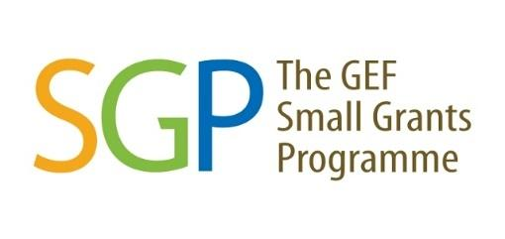
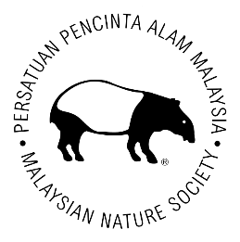



TERMS OF REFERENCE

for

SMALL GRANTS PROGRAMME
(SGP)

Call for Proposals

Klang Valley, Peninsular Malaysia

- Background

The Seventh Operational Phase (OP7) of the Global Environment Facility (GEF) Small Grants Programme (SGP) implemented by the United Nations Development Program (UNDP) in Malaysia aims to build upon the long-standing achievements of SGP in the country, specifically involving strengthening civil society organisations and improving socioeconomic conditions for local communities through the implementation of participatory conservation, restoration, and climate change mitigation interventions. Starting in this phase, Malaysia has been included in the Upgraded Country Programme (UCP) of the SGP.

With the aim of achieving impacts at scale and ensuring the sustainability of results achieved, the programme level strategy of the UCP is based on a landscape approach, following the United Nations Development Program (UNDP) approach of community-driven planning and management of socio-ecological production landscapes and seascapes. The three selected landscapes (Crocker Range Biosphere Reserve in Sabah; the Middle and Upper Baram River Basin in Sarawak; and the Klang Valley in Peninsular Malaysia) cover expansive and complex rural and urban geographies.

For OP7, its work in the Klang Valley (Figure 1) aims to address threats to biodiversity, including land degradation, as well as reducing climate change impacts by promoting energy efficiency. The goal is to improve land and resource management through community-driven interventions and generate global environmental benefits.

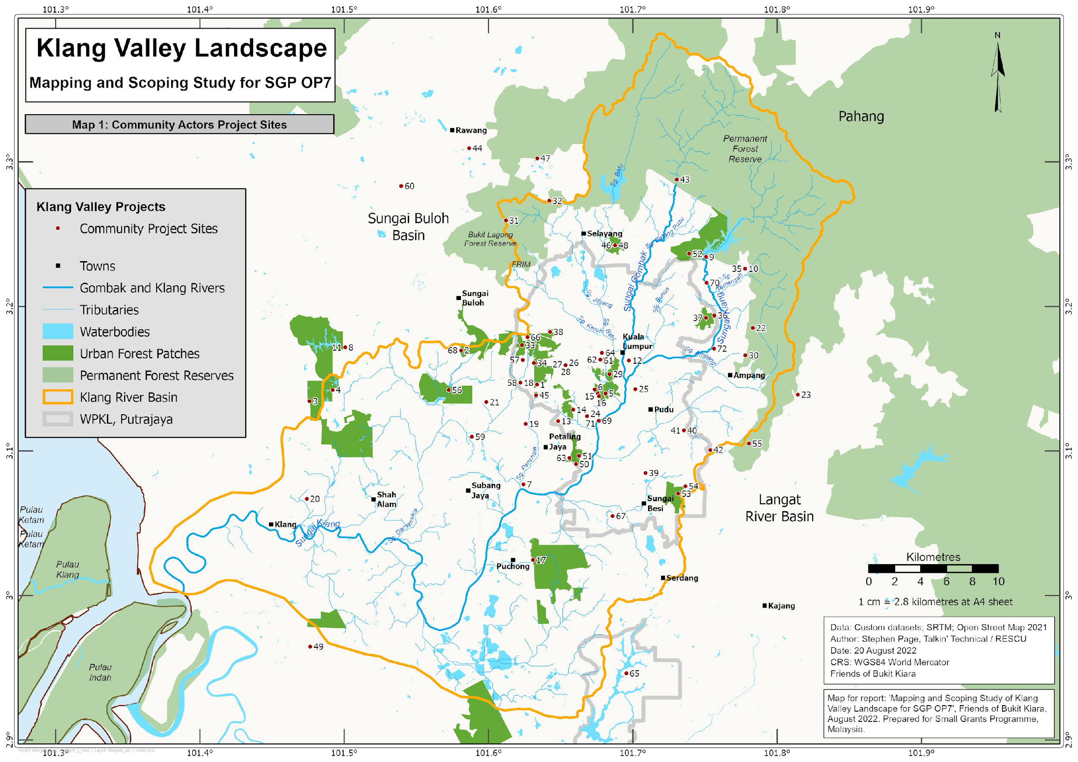
Figure 1. Scope of area for the Klang Valley landscape marked by the orange outline.
Under the Strategic Grant of GEF-SGP-UNDP OP7, the Rantaian Urban Green Spaces (RUGS) is a project led by the Malaysian Nature Society (MNS) that aims to steward and support community-led conservation efforts to safeguard, rehabilitate and connect isolated green spaces within the Klang Valley (Figure 2). Specifically, RUGS strives to create a green refuge that offers recreational opportunities and ecosystem benefits, such as mitigating the impact of the urban heat island effect, in addition to improving water and air quality for the city folks.

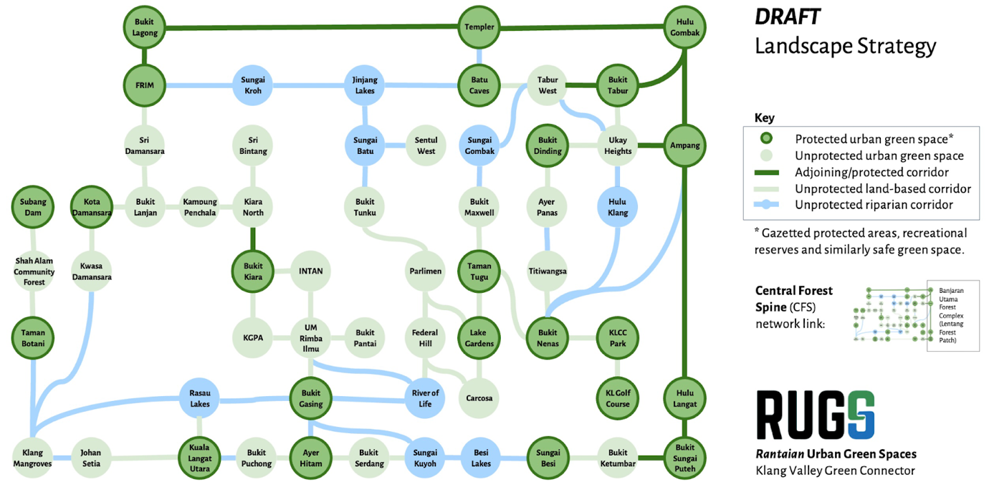
Figure 2. Green spaces and corridors in the Klang Valley landscape.

*Applicants should refer to the Klang Valley Landscape Strategy and ensure proposed activities align with this strategy.

  - Overview of Klang Valley Landscape Strategic Plan
The Klang Valley Landscape Strategy aims to identify the potential intervention strategies and foster collaboration among the key stakeholders such as NGOs, CBOs, governmental entities, academic institutes, private enterprises and local communities to achieve participatory landscape management for the protection and conservation of the green spaces within Klang Valley.

From the baseline assessment conducted by the MNS team, it is clear that the ecological linkages between the patches of green spaces within the Klang Valley persist, and holds significant diversity of flora and fauna. Collectively, these green spaces have the potential to positively impact the overall environmental health and promote sustainability, by counteracting the effects of climate change and providing essential ecosystem services (e.g. alleviate urban heat island effect, improve air and water quality, carbon sequestration). The MNS team has identified these potential linkages in the Klang Valley landscape (Figure 2), which will serve as the central focus of the landscape strategy, and guide community-based initiatives.

Various intervention strategies for community-based projects have been suggested, to achieve the core indicators / targets set forth by the SGP OP-7 for the Klang Valley. With the emphasis on community engagement and capacity building, these interventions include:
- landscape and vegetation restoration;
- improved forest and water management;
- advocating for policy and legal reforms;
- climate-resilient landscaping;
- carbon sequestration; and
- sustainable land use planning.

  - Project Objectives & Targets
The overarching objective of the RUGS project (in line with GEF-SGP-UNDP OP7), is to generate multiple benefits for biodiversity, climate change, land degradation, and the well-being of local communities through participatory, integrated land and resource management approaches implemented across the Klang Valley landscape.

The RUGS strategy, as an alternative to traditional approaches, seeks to reach this objective by pursuing the following four target outcomes by 2026:

- 400 hectares of land restored;
- 9,000 hectares of landscapes under improved practices;
- Greenhouse gas emissions mitigated equivalent to 150 tonnes of carbon dioxide; and
- 10,000 individuals directly benefiting

This will be accomplished and aided by SGP grant-funded projects within the Klang Valley, led by NGOs, CBOs, and local communities.

- Scope of Assignment and Indicative Activities

Competent organisations are encouraged to submit an application based on the following Call for Proposals. Proposals will be reviewed and approved by the SGP National Steering Committee (NSC).

Mandatory requirement:
- Proposed project must contribute to the SGP core indicators / targets (as outlined in Section I-B).
- All proposed project activities must align with the Klang Valley Landscape Strategy that is prepared by MNS in consultation with other stakeholders. The landscape strategy is under development, so please contact the SGP Secretariat to obtain the latest version.

Applicants shall consider one or more of the following activities (but not limited to) for their proposed project:

- Land Restoration
- Vegetation restoration and reforestation in degraded parts of the RUGS landscape (e.g. development areas, logged forests, abandoned areas, etc.).
- Erosion and soil stabilisation within vulnerable landscapes such as riverbanks within RUGS riparian corridors (e.g., Klang River Basin) through restoration of stream-side vegetation; and hillslopes.

- Sustainable Land and Forest Management
- Legal protection and improve land management over the existing and proposed community forests and green spaces in the Klang Valley.
- Development of land use policies and regulations that promote protection of green spaces, sustainable urban planning, land use and development practices.
- Development of nature-based economic opportunities for local communities (e.g., agroforestry, urban farming, ecotourism, etc.).
- Documentation of traditional knowledge related to landscape management and restoration techniques.

- Biodiversity
- Strengthen community forest and land management through capacity building and engagement with relevant authorities.
- Physical intervention and enhancement of degraded landscape by creating diverse and resilient habitats such as wildlife corridors/crossings and man-made wetlands, through collaboration with city planners and architects.
- Development of policies and regulations for managing wildlife and its habitats.
- Strengthen community-based conservation of threatened species via citizen-scientist programmes to provide opportunities for learning about scientific concepts and contributing to biodiversity conservation.
- Documentation of traditional knowledge related to biodiversity.
- Green spaces accessibility to urban poor communities and demonstration of urban biodiversity initiatives to alleviate urban poverty.

- Climate Change mitigation
- Strategic urban planning and design that incorporates energy-efficient and climate-resilient buildings using green materials and technologies that also have value as habitat for wildlife within the RUGS network (e.g., energy efficient lighting, roofing, and walls).
- Carbon offset systems such as carbon taxing and cap-and-trade systems to incentivise emissions reductions and restoration of carbon sinks (particularly degraded peatlands).
- Climate-friendly practices for sustainable agriculture, fisheries or other industries and food security within RUGS green spaces and corridors.
- Strengthen renewable energy interventions (e.g., off-grid solar combined cooling, heating and power (CCHP) for urban communities, biomass gasification).
- Promote sustainable transportation via public transportation network and improve accessibility by foot.

- Eligible Organisations & Funding Criteria

- Locally registered Non-government Organisations (NGOs) / Civil Society Organisations (CSOs) / Community-based Organisations (CBOs), with an existing copy of the certificate of registration.
- Locally registered bank account of the organisation.
- In exceptional circumstances, unregistered organisations may contact the SGP Secretariat to discuss the potential arrangement of an intermediary contract with an established organisation.
- Applicant organisations must demonstrate that it has the capacity to implement the project and meet SGP’s administrative and book-keeping requirements.
- Applications may be written in either English or Bahasa Malaysia.
- Applications must be complete and submitted using the provided template (Concept Proposal Template). All applications using other templates will not be considered.

- Duration of Project

All projects must be completed by December 2025 at the latest.

- Grant Amount
The maximum amount per grant award will be limited to USD50,000. It is advisable that applicants base their grant request on the estimated expenditure required to conduct the proposed activities. Applicants are required to provide estimate budgetary using the provided template. The funds will be distributed on a milestone completion basis.

- Relevant Documents

Applicants MUST submit the following documents using the provided templates:
- Concept Proposal Template: English / Bahasa Malaysia

- Proposal Assessment Criteria

Grant applications will be reviewed by the NSC members and deliberated during the NSC Meeting. The following criteria are used to assess all applications:

- Relevance of the Project Activities: Must be consistent with the SGP OP-7 Project Document and Klang Valley Landscape Strategy draft and contribute to SGP core indicators / targets.
- Design of the Proposed Project: Consists of problem statement, justification, objectives, project activities, measurable outputs and results/outcomes, stakeholder and community engagement plan, knowledge management plan, project implementation timeframe, project risks, and monitoring & evaluation plan.
- Project Implementation and Management Capacity: Must be able to demonstrate strong organisational capacity to implement SGP grant projects and meet SGP requirements.
- Co-financing: Applicants must provide any co-financing commitments.
- Sustainability of the Project: Must have tangible impacts, potential for upscaling and/or replication, sustainable financial viability, positive influence on policy and environmental impact.
- Budget and cost-effectiveness of the action: Proposed budget for each activity must be reasonable and cost-effective.

- Grant Application Process
Please refer to the grant flowchart below for an overview of the grant application process:

NO
YES
Start
Call for grant application
Applicant completes SGP proposal and submit to National Coordinator & Program Assistant

Secretariat reviews the proposal and provides feedback on the proposal (if needed)

Applicant revises proposal based on feedback (if needed)

Applicants revise their applications based on comments provided by NSC and resubmit to the secretariat
NSC members review applications
ZZs
Successful?

Applicant receives decline email

Application status: Approved
Application status:
Approved with comments

Applicants revise their application for resubmission

Grant awarded to successful applicants
MOA signing and disbursement of 1st tranche
Application status: Revised and resubmit
Application status: Rejected

End
NSC members review and approve applications

Completed proposal should be submitted to the SGP National Coordinator by 18 February 2024 with subject titled: Concept Proposal SGP for Klang Valley_(Name of Organisation)

Only qualified applicants will be notified.

For proposal submission and more information, please contact:

Lee Shin Shin
SGP National Coordinator
GEF Small Grants Programme – Malaysia
Tel: +603 8689 6055
Email: shin.shin.lee@undp.org

Nurul Fitrah Mohd Ariffin Marican
Programme Assistant
Email: nurul.fitrah.mohd.ariffin.marican@undp.org

For proposed location within Klang Valley, but outside the boundary, please contact the SGP Secretariat for consultation.

